Recursive Tree Approach

It is one of the method to solve Recursive Term , previously we learn substitution method this is 2nd method Tree Method

In Substitution method we substitute the n until it goes into the base condition T(n)

When Should we Use Recursive Tree Approach :

We all, see in previous Substitution there is only one Recursive term

But if there is more than one recursive term we use Tree Approach

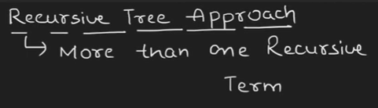

Example :

The Recursive term is

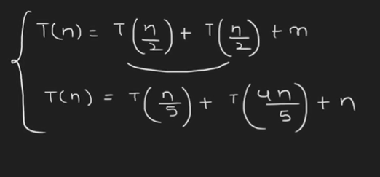

In this there two example each one has is Two Recursive Term and one non recursive term

Problem 1 :

T(n) = T(n/2) + T(n/2) +n

The Name suggest it works on the tree based

N = n2 and n2

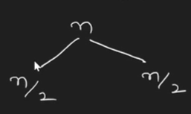

Here the n cost requires to solve big problem into small picese

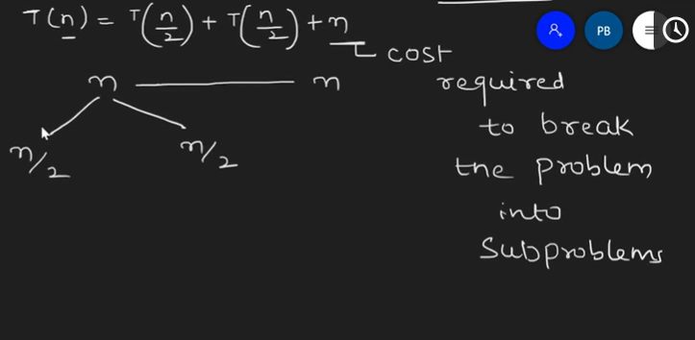

The model is :

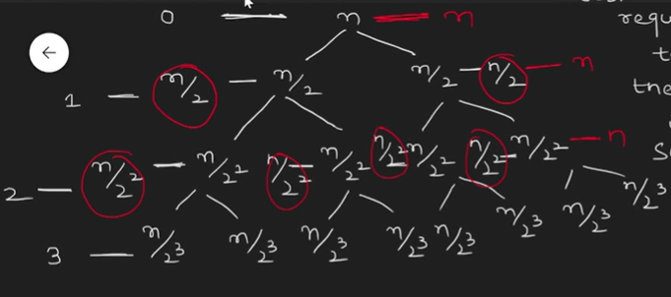

The n in red color is the Cost Problem, and tree works on level based top node is level 0 and last is level 3

The Time Complexity is :

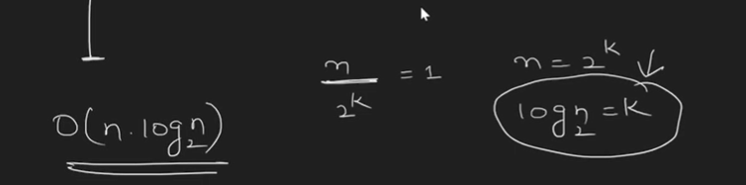

Time complexity 🡺 O(n . log2n)

It can also solve by Substitution method but the time complexity is same .